OFFICE OF THE COMMANDER-IN-CHIEF
NAVAL HOME COMMAND
PORTSMOUTH POl 3LR
R/Scouts/28/79 Tel: Portsmouth 22351 Ext. 23077
Telex No: 86174

The Activities Secretary (3)
The Scout Association
Gillwell Park
Chingford
London E4 7QW 3 May 79

MOD RECOCOGNITION – 4TH GILLINGHAM {RAINHAM} SEA SCOUT GROUP

1. I am pleased to inform you that as a result of an Inspection on 27 April 1979 Ministry of Defence Recognition of 4th Gillingham Sea Scout Group has been renewed for a further period. A Recognition Certificate has been forwarded to the Group Scout Leader.

2. a. Group Strength

Venture Scouts (Mixed): 14
Sea Scouts: 33 (in addition 12 under 12 years of age)
Cub Scouts: 52 (2 Packs)

b. General Assessments

General Appearance: VG Bearing: VG
Dress: Good/VG Drill: Good/VG
Knowledge: Good Badgework: Good

3. This was an indoor inspection attended by the Assistant County Commissioner for Activities, District Commissioner accompanied by his Assistant for General Duties, the Group Chairman, members of the Group Executive and a number of parents/friends.

4. The inspection was well planned and enjoyable with every effort being made to meet the occasion. Attendance was excellent; the youngsters extremely smart, badgework, drill and ceremonial above average, and activities well presented and interesting.

5. Leaders are adequate to meet membership throughout the various sections, a
good well balanced training programme is in existence, and through good leadership, the youngsters are well motivated and morale high. The Group is administered by a dedicated and active Executive Committee supported by a number of parents, but parental support could be improved. Problems with finance and local policy is impeding the extension of the Group's HQ premises. It is hoped that these matters will be resolved as increased membership demands larger premises. The mixed Venture Scout Unit is gaining in strength and meeting a good training programme. Quite a number of Venture and Coxswain awards have been gained and one young lady received her Queen's Scout award at the inspection. These teenagers by their smartness and example are a credit to their Leaders and the Group - well done!

6. I congratulate the Venture Scout who has been selected for service with the Royal Navy and wish him success in his career.

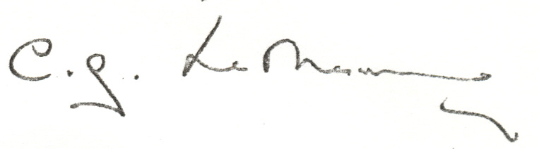
C G Le MESURIER
Captain, Royal Navy
Chief Staff Officer (Reserves) to
Commander-in-Chief
Naval Home Command

Information:

The Staff Officer (Scouts) (2)

L J Brown Esq, 40 Elmstone Road, Rainham, Kent"(with Recognition Certificate)

B M Fitzpatrick Esq, 29 Edwin Road, Rainham, Kent

Lieutenant Commander H A Monk DSM, 152 Hempstead Road, Gillingham, Kent

Lieutenant (CS) G G Shipway RM, RN and RM: Careers Officer,
1 Dock Road, Chatham, Kent, ME4 4JR

P F Lankester Esq (Field Commissioner), Ryedale, Cross in Hand Road,
Heathfield, Sussex TN21 OUR

RB

