OFFICE OF THE COMMANDER-IN-CHIEF
NAVAL HOME COMMAND
PORTSMOUTH PO1 3LR
R/Scouts/42/78 Tel: Portsmouth 22351 Ext. 24463
Telex No: 86174

The Activities Secretary (3)
The Scout Association
Gillwell Park
Chingford
London 16 May 78

MOD RECOGNITION - 4TH GILLINGHAM SEA SCOUT GROUP

1. I am pleased to inform you that as a result of an inspection on 11 May 78 Ministry of Defence Recognition of 4th Gillingham Sea Scouts has been renewed for a further period. A Recognition Certificate has been forwarded to The Group Scout Leader.

2. a. Group Strength

Venture Scouts: (Mixed Unit) 8
Sea Scouts: 32 (In addition 10 Under 12 Yrs of Age)
Cub Scouts: 2 Packs (1 x 24) (1 x 28)

b. General Assessment

General Appearance: Sat/Good Badgework: Good/VG
Dress: Sat Drill: Good
Bearing: Good Knowledge: Good

3. This was an outdoor inspection with afloat activities undertaken on the river Medway adjacent to the Naval Base at Chatham. The inspection was attended by the Assistant County Commissioner (Activities), the Group's Chairman together with Officers of the Group Executive Committee, District and Assistant District Commissioners and a number of Parents.

4. Afloat activities were extremely well undertaken with five Mirror Dinghies, One GP and one Sandpiper class dinghies undersail, together with a gig being used for boat pulling and a powered safety craft. The standard of sailing and boat handling was quite high with local incidents introduced by the Inspecting Officer being very well handled.

5. The formal inspection held in the HQ premises showed the youngsters to be generally smart in their appearance and dress although the standard was lowered by non-uniformity in the wearing of dark trousers and black shoes as well as a number of Scouts parading in badly shaped caps. Badgework is progressing well although a number of individuals require to make a greater effort to gain awards. Drill and ceremonial were well attempted and the members were quite knowledgeable in both pure scouting and nautical subjects.

6. The Mixed Venture Scout Unit is gradually increasing in numbers and their members working hard to gain Venture awards.

7. The Group is soundly administered by an active and dedicated Executive Committee, who plan to provide an extension to the HQ premises and renew boats/ equipment in the near future. Leaders are barely adequate in number though first class in quality. A well-balanced training programme is in evidence to provide the youngsters with a wide variety of pursuits to hold their interest and increase their efficiency. HQ premises and support facilities are good but parental support remains below average and it is hoped that this situation will improve.

8. This was a good and enjoyable inspection with the only real criticism being
dress.

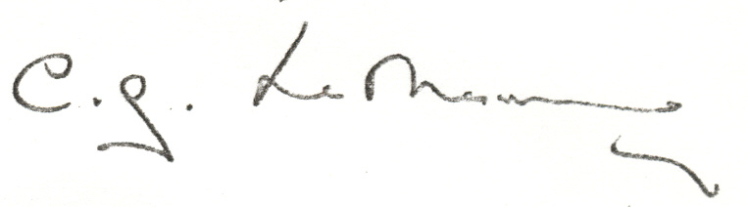
C G Le MESURIER
Captain Royal Navy
Chief Staff Officer (Reserves) to
Commander-in-Chief
Naval Home Command

Information:

Staff Officer (Scouts) (2)
B Fitzpatrick (Assistant GSL)
Group Scout Leader
4th Gillingham Sea Scouts
29 Edwin Road
Rainham Near Gillingham Kent (with Recognition Certificate)

Lieutenant Commander H A Monk DSM RN (Retd)
152 Hempstead Road
Gillingham Kent

PG

